Multi-Factor Authentication (MFA) Deployment using Microsoft Entra ID

1. Introduction
Multi-Factor Authentication (MFA) is a critical security control in Identity and Access Management (IAM) that enhances account protection by requiring multiple forms of verification. It significantly reduces the risk of unauthorized access, even if user credentials are compromised.
This project demonstrates the deployment and enforcement of MFA using Microsoft Entra ID, including configuration, user enrollment, testing scenarios, and validation using authentication logs.

2. Objective
The objectives of this project are to:
- Implement Multi-Factor Authentication (MFA) for user accounts
- Strengthen identity security using additional verification factors
- Simulate real-world authentication scenarios
- Validate MFA enforcement using logs
- Demonstrate Zero Trust security principles

3. Tools & Technologies Used
- Microsoft Entra ID (Azure Active Directory)
- Azure Portal
- Microsoft Authenticator App
- MyApps Portal
- Sign-in Logs

4. Architecture Overview
The MFA architecture consists of:
- Identity Provider: Microsoft Entra ID
- User: Jane (Test User)
- Authentication Factors:
  - Password (Something you know)
  - Authenticator Approval (Something you have)

Authentication Flow:
User → Password → MFA Prompt → Access Granted
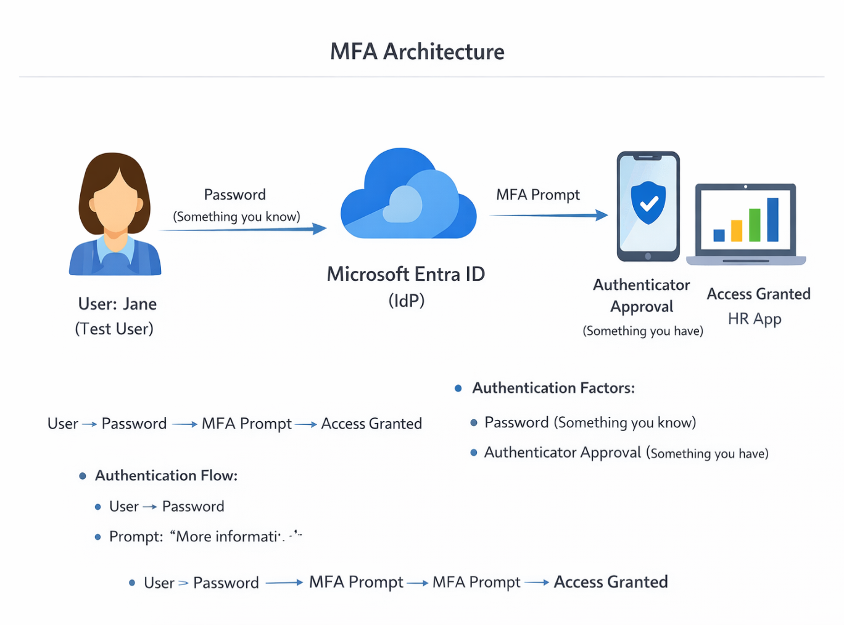

5. MFA Configuration

5.1 Enabling Security Defaults
Due to free-tier limitations, MFA was enforced using Security Defaults.

Steps:
- Navigate to Microsoft Entra ID
- Go to Properties
- Select “Manage Security Defaults”
- Enable Security Defaults
Result: MFA enforced for all users in the tenant.
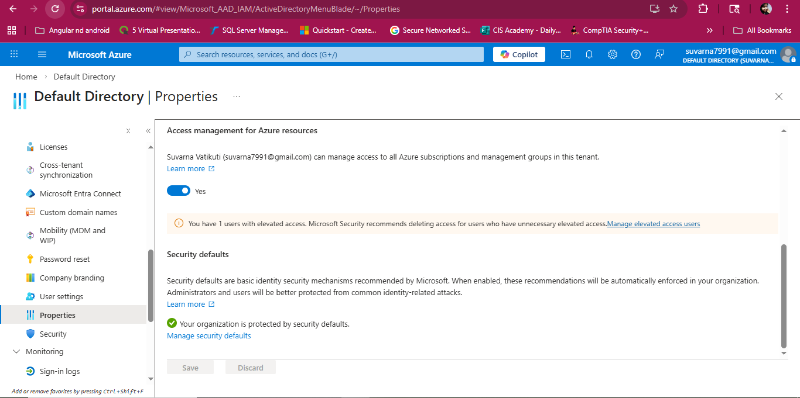
Security Defaults Enabled

6. User Enrolment (MFA Setup)

Steps:
- Login as user (Jane)
- Prompt: “More information required”
- Select Microsoft Authenticator
- Scan QR code
- Approve notification
Result: MFA successfully registered for the user.
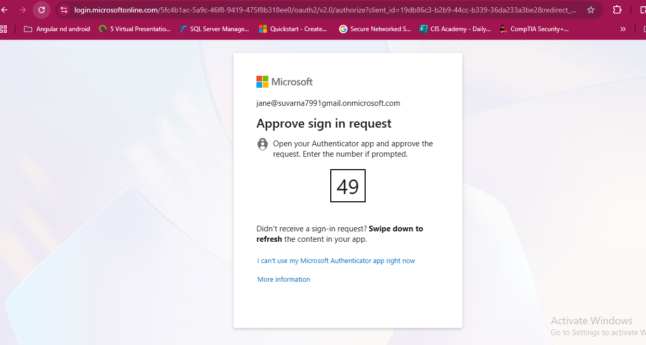Microsoft Authenticator Setup Success

7. Authentication Scenarios Testing

7.1 Successful Login
- Enter correct username and password
- Approve MFA request
Result: Access granted
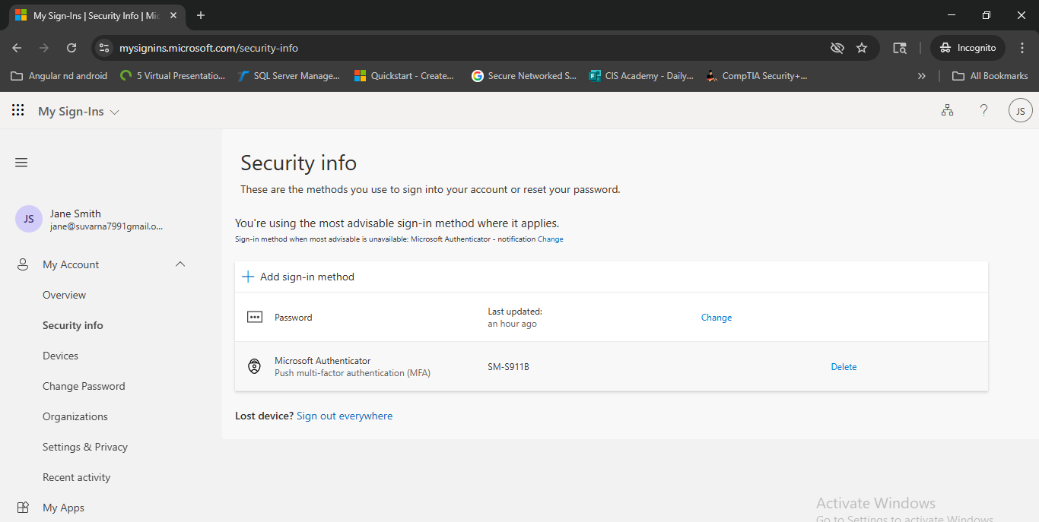

7.2 Failed Login (Wrong Password)
Result: Authentication failed with providing wrong password and if happens multiple times then account gets locked.
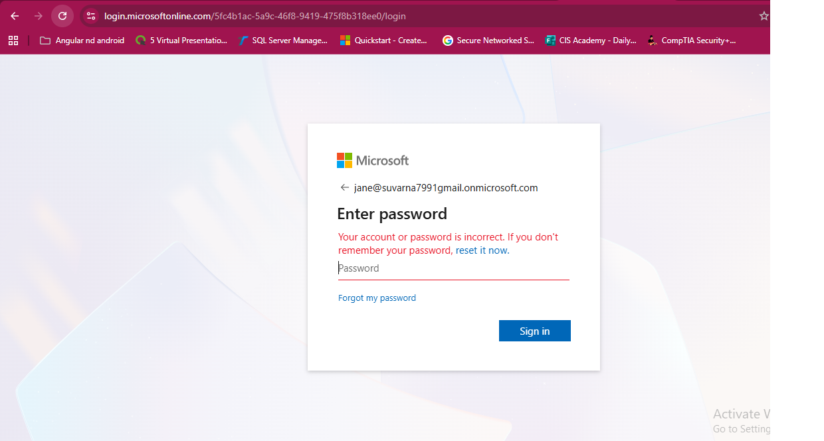

7.3 MFA Denied Scenario
- Enter correct password
- Deny MFA request
Result: Access denied
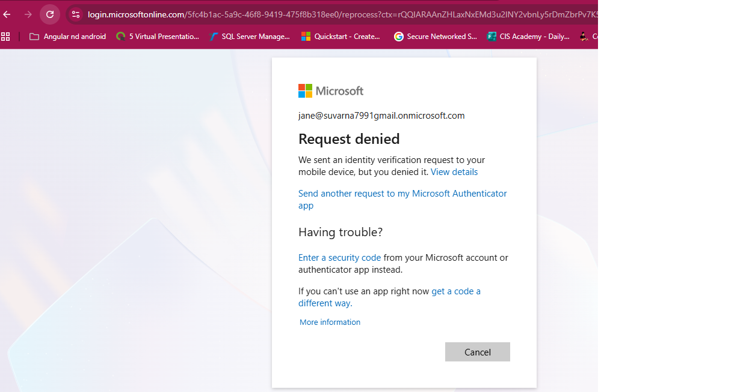

7.4 Session-Based Authentication
- Login once successfully
- Re-access application
Observation:
MFA prompt may be skipped or only MFA requested due to session persistence.

8. Risk Simulation

Scenario: New Device / Browser
- Login using incognito mode
Result: MFA triggered again

Scenario: Multiple Failed Attempts
- Enter wrong password multiple times
Result: Account temporarily locked
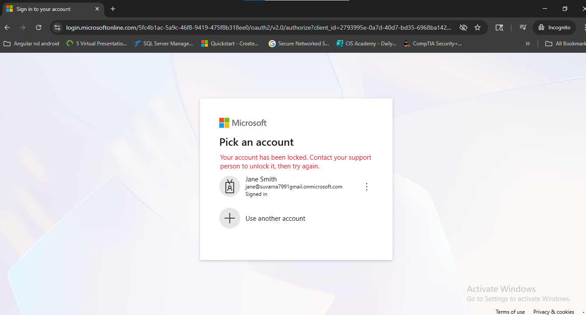

9. Log Monitoring and Validation

Steps:
- Navigate to Entra ID → Sign-in Logs and Filter by user (Jane)

Observations:
- Successful login events recorded and failed login attempts visible.
- MFA requirement logged and device along with location information available.
Result: Full visibility of authentication events
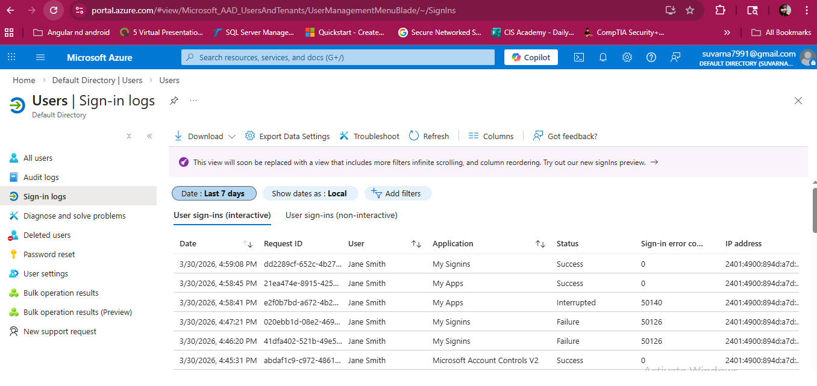

10. Security Principles Implemented
- Multi-Factor Authentication (MFA)
- Zero Trust Security Model
- Least Privilege Access
- Strong Identity Verification
- Continuous Monitoring

11. Challenges and Solutions
Challenge | Solution
No Conditional Access | Used Security Defaults
MFA not prompting | Tested using incognito / new session
Session caching confusion | Validated behavior with multiple logins
Limited advanced features | Simulated real scenarios manually

12. Key Learnings
- MFA significantly improves account security
- Authentication behavior varies based on session and device
- Logs are critical for validating IAM controls
- Even basic MFA setup can simulate enterprise security

13. Conclusion
This project successfully demonstrates the deployment and enforcement of Multi-Factor Authentication using Microsoft Entra ID. By combining password-based authentication with an additional verification factor, the system ensures strong identity validation and protection against unauthorized access.
The implementation aligns with modern Zero Trust principles and provides a strong foundation for enterprise identity security.

14. Future Enhancements
- Implement Conditional Access policies
- Enable password less authentication (FIDO2 / Windows Hello)
- Integrate with real enterprise applications
- Automate MFA configuration using PowerShell
- Apply risk-based authentication policies

